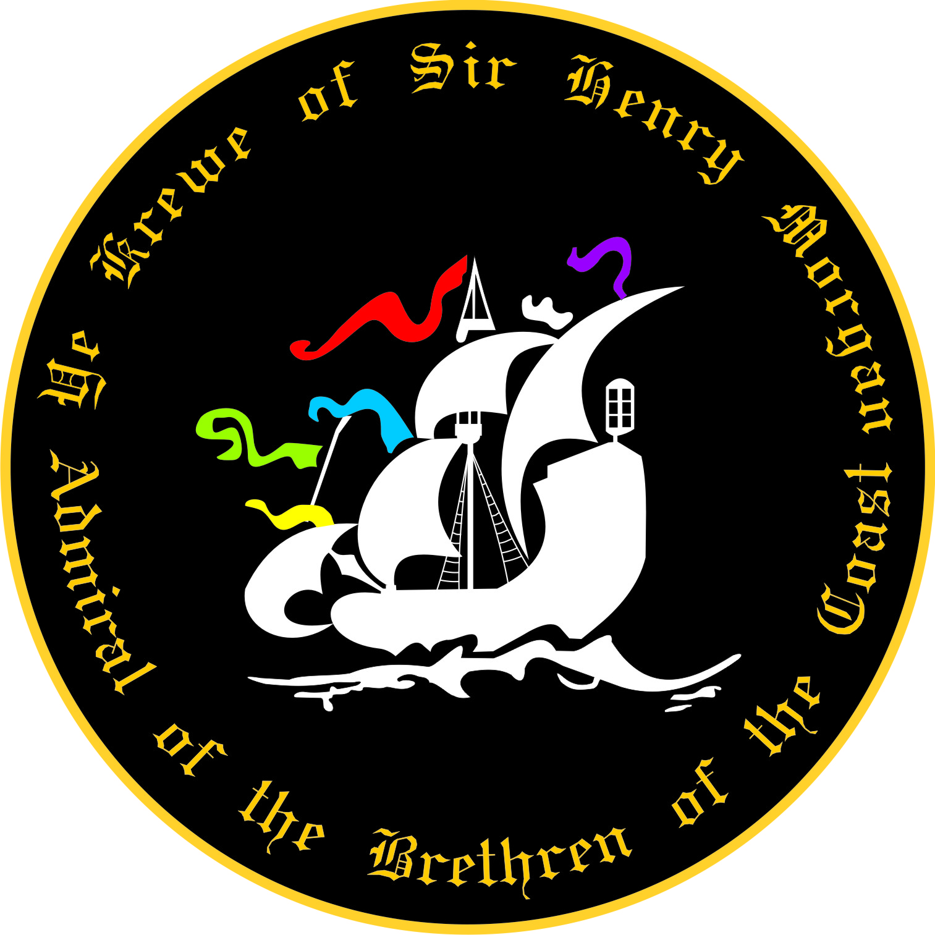
2020 Membership Application
Ye Krewe of Sir Henry Morgan Membership

Name:Click here to enter text. Date:Click here to enter text.

Address: Click here to enter text.

Cell Phone: Click here to enter text.
Home Phone: Click here to enter text.

Birth Date (Applicant must be 21 years or over):Click here to enter text.
E-Mail:Click here to enter text.

The following Krewe member has agreed to sponsor me for membership: Signature of Member is required!!

Print Name: __________________________________ Signature:___________________________________

I understand this is an application only, and that membership is subject to approval by YKSHM Board of Directors. Application must be accompanied by the current year’s dues of $390.00.

If my application is not accepted, all monies will be refunded within 7 days of decision.
Annual dues shall be $390.00 per year. The Treasurer will bill all members August 1st of each fiscal year. All dues are to be paid in full, no later than September 6th, or member may be subject to a late fee.

Those whose dues are not paid in full by November 1st, will no longer be member in good standing and may be dropped from the membership and removed from the Krewe Roster.

The Krewe has a NO-REFUND policy for dues and memberships are nontransferable.

I understand that no medical or injury coverage is provided on my behalf, in the event of injury, during a Krewe function. I also agree to hold harmless Ye Krewe of Sir Henry Morgan, any of its members, officers, directors, contractors or sponsors liable for any personal injury or liabilities incurred throughout my participation in any of its activities.

I agree to follow all rules and regulations YKSHM, or will be subject to removal from membership.

Initial: I understand that I am to supply my own throw beads for each parade and that they must be LEAD FREE as per the Parade Administrators requirements.

My signature below attests that I have read and understand and will abide by all information above.

Signature_________________________________________________ Date ______________

Please email this document to treasurer@henrymorgankrewe.organd pay fees on line at www.henrymorgankrewe.org OR Mail this application and check to:

Ye Krewe of Sir Henry Morgan, ATTN: Membership Application P.O. Box 18735, Tampa, FL 33679-8735

Questions? Email skribe@henrymorgankrewe.org for assistance

Ye Krewe of Sir Henry Morgan
Parade Participant Release Agreement-2020

I ( Click here to enter text. ) will be participate in the 2020 parade(s) season:

This waiver form is to be signed by all participants (including Marshals and Guests)

In consideration of the acceptance of my participation in the parade(s), I, the undersigned participant, intending to be legally bound, do hereby for myself, my heirs, executors, administrators and assigns, forever waiver, release and discharge any and all rights, claims and actions for damages that we or any of us may have, or that may hereafter accrue to us or any of us, against any and all persons, organizations and entities associated with the event including but not limited to Ye Krewe of Sir Henry Morgan, the board of Ye Krewe of Sir Henry Morgan, arising out of or in connection with my entry in, travel to, participation in, and return from the parade(s). I attest that I am physically fit, in good health, suffer from no physical infirmities and am fully able to participate I this/these event(s), including walking the entire parade route, if necessary.

Initial: I understand that special accommodations cannot be made for injury, bodily harm and/or property
damage.

Initial: I understand that traffic control will cease at the end of the parade route(s).
I also give my permission for the free use of my name and/or pictures in broadcasts, telecasts,
newspapers, web pages, etc.

Initial: I understand Ye Krewe of Sir Henry Morgan is not responsible for lost or stolen personal possessions.

Initial: I understand that I am to supply my own throw beads for each parade.

I have read, understand and will abide by the Krewe Rules.

Signature of Participant _______________________________________________ Date _____________________

Printed Name _______________________________________________

Emergency Contact: _______________________ Relationship _________________ Phone _________________

Emergency Contact: _______________________ Relationship _________________ Phone _________________

Medical Insurance Carrier _________________________________________ Policy Number ___________________

List any Allergies, Health Issues; such as, asthma, diabetes, heart problems, etc.

______________________________________________________________________________________________
______________________________________________________________________________________________

