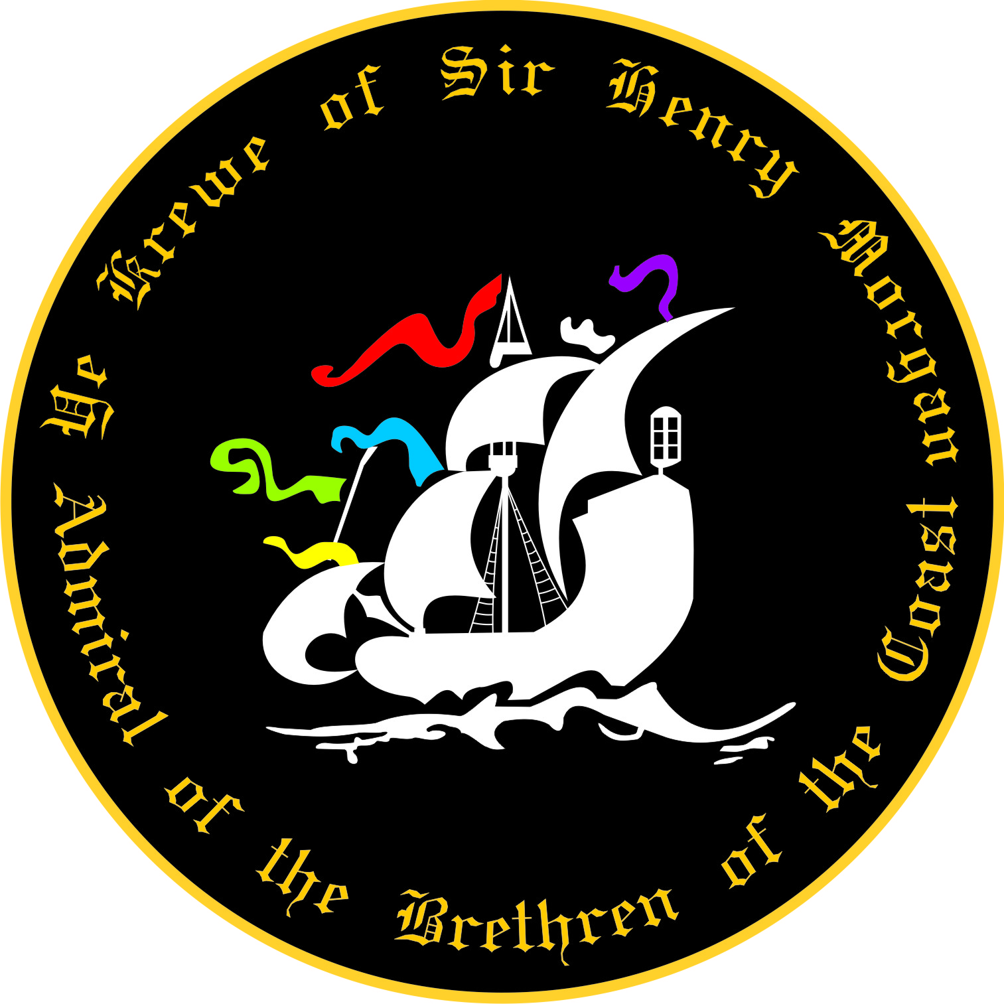

Bar Stool Rental for 2020 Parade Season
(Please Print)
This form serves as a request for a Bar Stool Rental for Parade Season 2020. Bar Stool rentals are subject to a first come, first serve basis. Prior to submitting payment, it is suggested you contact our Treasurer at treasurer@henrymorgankrewe.org for stool availability.
Submission of completed form and fee guarantees that you will have a stool. It does NOT guarantee that your stool will be by the railing. Placement is subject to space and first come first serve.
Name: ___________________________________________________________________________________
Name as it should appear on the stool:______________ __________________________________________
Address: _________________________________________________________________________________ Cell Phone: _____________________________ Home Phone: ______________________________________ E-Mail: __________________________________________________________________________________ Number of Bar Stools Requested:_______________ __________________________________
Fee: $ 50.00 per stool, per year.
Print Name: __________________________________ Signature:___________________________________
Mail this form and all Monies ( OR fill out form and pay online at www.henrymorgankrewe.org) to: Ye Krewe of Sir Henry Morgan, ATTN: Bar Stool Rental P.O. Box 18735, Tampa, FL 33679-8735 For questions email: Treasurer • Email- Treasurer@henrymorgankrewe.org

