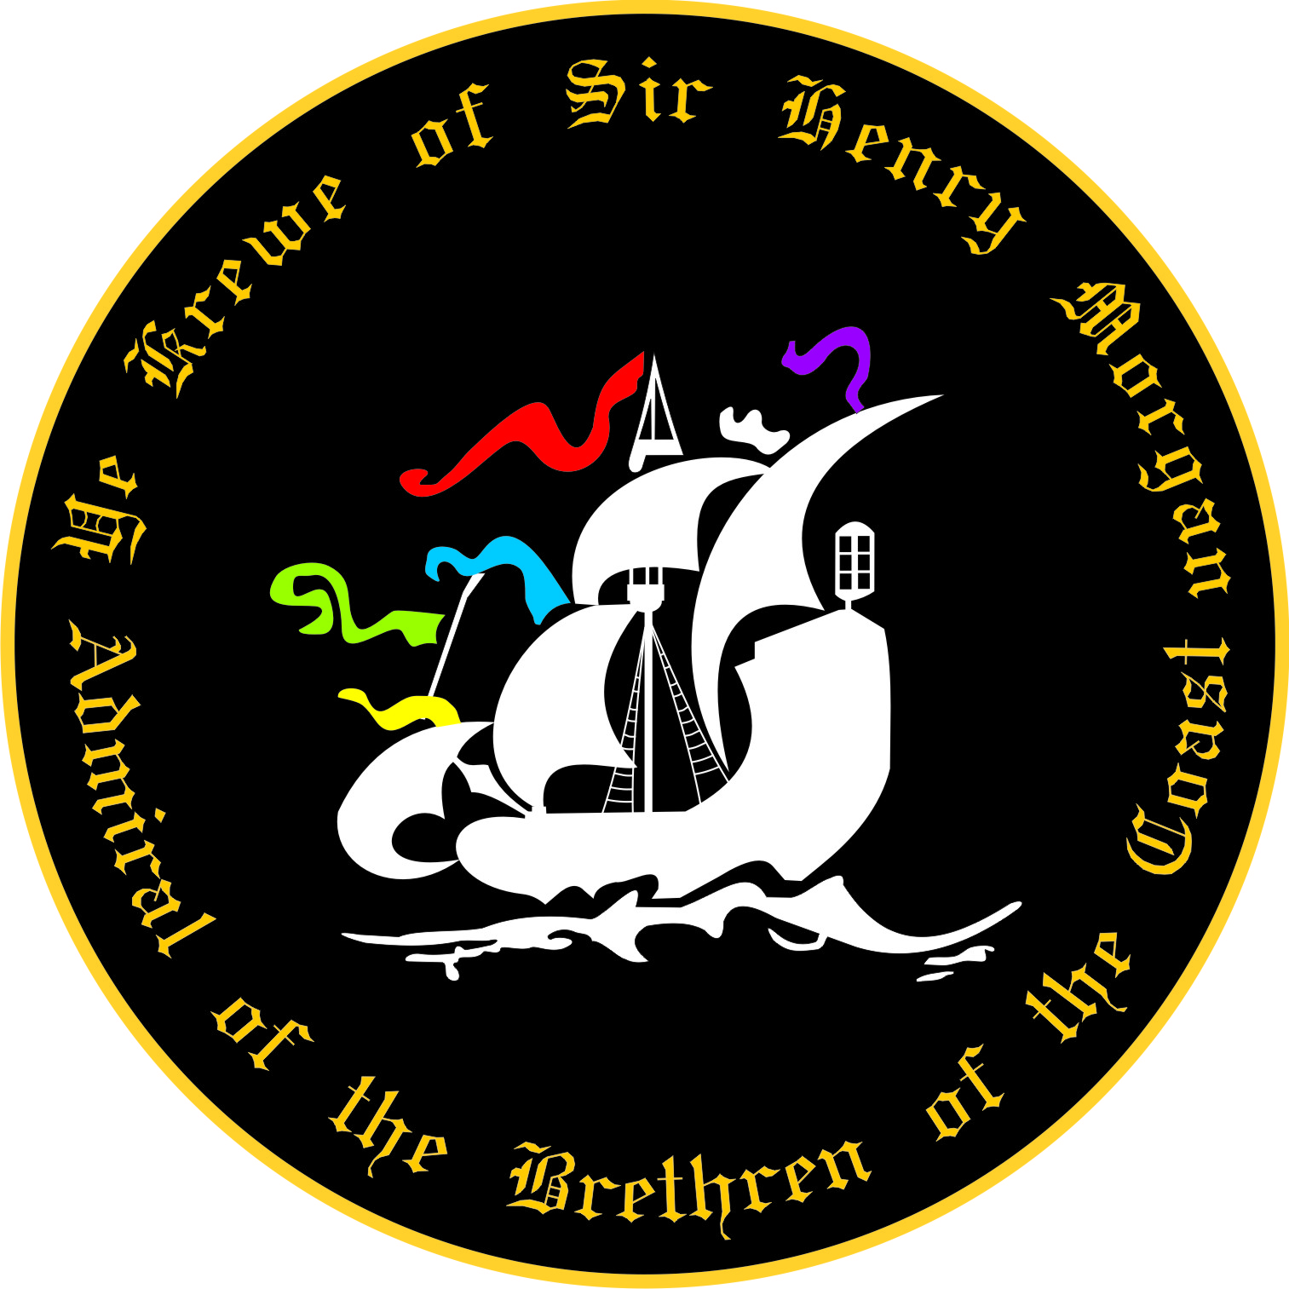
2020 Security Application
Ye Krewe of Sir Henry Morgan

Name: Click here to enter text. Date: Click here to enter a date.
Occupation/Profession: Click here to enter text.
Home Phone: Click here to enter text.
Cell Phone: Click here to enter text.
E-Mail Address: Click here to enter text.

Home Address: Click here to enter text.
City/State/Zip:Click here to enter text.
Emergency Contact Name: Click here to enter text.
Emergency Contact Phone: Click here to enter text.

Parade you will be security for: Click here to enter text.

I hereby apply for Security for Ye Krewe of Sir Henry Morgan, Admiral of the Brethren of the Coast and certify that I am over 21 years of age and, if accepted, am solely responsible for my actions at any Krewe function and will not hold the Krewe responsible for any harm to my persons or possessions. I further agree to abide by the rules and regulations set forth by this organization.

This Form must be accompanied by the “Parade Participant Release Agreement Form”

Signature ___________________________________________________Date ________________________

Signature of Referring Member ______________________________________________________________

I am interested in joining Ye Krewe of Sir Henry Morgan Yes No Please check one

Please email this document to treasurer@henrymorgankrewe.org or bring it with you to the Bead Drop for the parade you plan to be security for.

Questions? Email skribe@henrymorgankrewe.org for assistance.

Ye Krewe of Sir Henry Morgan
Parade Participant Release Agreement

I ( Click here to enter text. ) will be participate as security in the 2020 parade(s) season:

This waiver form is to be signed by all participants (including Marshals and Guests)

In consideration of the acceptance of my participation in the parade(s), I, the undersigned participant, intending to be legally bound, do hereby for myself, my heirs, executors, administrators and assigns, forever waiver, release and discharge any and all rights, claims and actions for damages that we or any of us may have, or that may hereafter accrue to us or any of us, against any and all persons, organizations and entities associated with the event including but not limited to Ye Krewe of Sir Henry Morgan, the board of Ye Krewe of Sir Henry Morgan, arising out of or in connection with my entry in, travel to, participation in, and return from the parade(s). I attest that I am physically fit, in good health, suffer from no physical infirmities and am fully able to participate I this/these event(s), including walking the entire parade route, if necessary.

Initial: I understand that special accommodations cannot be made for injury, bodily harm and/or property
damage.

Initial: I understand that traffic control will cease at the end of the parade route(s).
I also give my permission for the free use of my name and/or pictures in broadcasts, telecasts,
newspapers, web pages, etc.

Initial: I understand Ye Krewe of Sir Henry Morgan is not responsible for lost or stolen personal possessions.

Initial: I understand that I am to supply my own throw beads for each parade.

I have read, understand and will abide by the Krewe Rules.

Signature of Participant _______________________________________________ Date _____________________

Printed Name _______________________________________________

Emergency Contact: _______________________ Relationship _________________ Phone _________________

Emergency Contact: _______________________ Relationship _________________ Phone _________________

Medical Insurance Carrier _________________________________________ Policy Number ___________________

List any Allergies, Health Issues; such as, asthma, diabetes, heart problems, etc.

______________________________________________________________________________________________
______________________________________________________________________________________________

