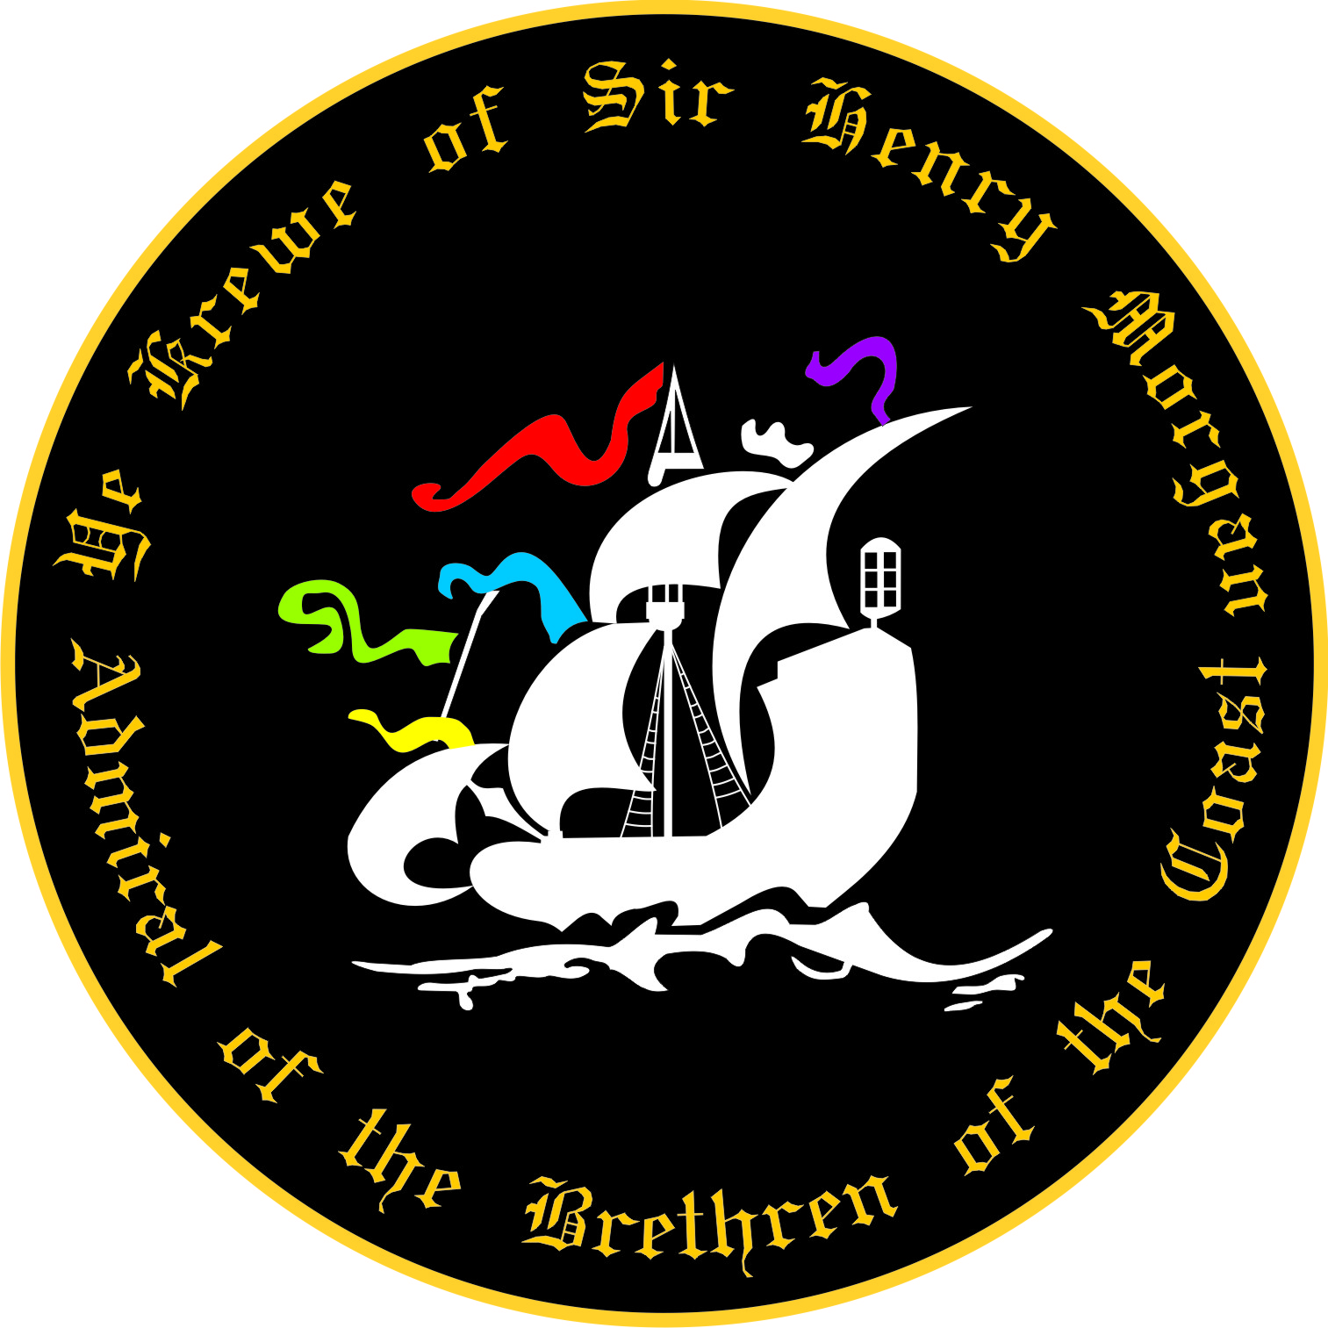
2020 Children’s Parade Application for
Ye Krewe of Sir Henry Morgan

Name: Click here to enter text. Date: Click here to enter text.
Address: Click here to enter text.
Cell Phone: Click here to enter text.
Home Phone: Click here to enter text.
E-Mail: Click here to enter text.

I am a:
Guest ☐
Current Member (2020 Fees have been paid) ☐

The following Children will accompany me: (Maximum 2 Children per paid guest or member):
Name: Click here to enter text. Age of Child: Click here to enter text.
Name: Click here to enter text. Age of Child: Click here to enter text.

The following Krewe member has agreed to sponsor me as a Guest: Signature of Member is required!!

Print Name: Click here to enter text. Signature:___________________________________

- I understand this is an application only, is subject to approval by YKSHM Board of Directors.
- Application must be accompanied by the current year’s guest fees or paid membership.
- If my application is not accepted, all monies will be refunded within 7 days of decision.
- Guest fees for 2020 Children’s parade are $60.00/guest 21 years of age and older.
- The Krewe has a NO-REFUND policy for dues and guest fees. Memberships and guest fees are nontransferable.
- I understand that no medical or injury coverage is provided on my behalf, in the event of injury, during a Krewe function. I also agree to hold harmless Ye Krewe of Sir Henry Morgan, any of its members, officers, directors, contractors or sponsors liable for any personal injury or liabilities incurred throughout my participation in any of its activities.
- I agree to follow all rules and regulations of YKSHM, or will be subject to removal from membership or as a guest.

Initial: I understand that I am to supply my own throw beads for each parade.
Initial: I understand that the Children I bring with me to the event will be under my supervision for the entire
Event.
Initial: I understand that children under the age of 10 are to ride on the parade float.
Initial: I understand that Children 10 and older are expected to walk for the parade.
Initial: I understand that the Children’s parade is a Non-Alcohol event, and I am not to bring or drink alcohol during the parade or I will be removed from the parade and possible membership.
My signature below attests that I have read and understand and will abide by all information above.

Signature_________________________________________________ Date ______________

Please email this document to treasurer@henrymorgankrewe.org and pay fees on line at www.henrymorgankrewe.org OR Mail this application and check to:
Ye Krewe of Sir Henry Morgan, ATTN: Children’s Parade Application
P.O. Box 18735, Tampa, FL 33679-8735

Questions? Email skribe@henrymorgankrewe.org for assistance

Ye Krewe of Sir Henry Morgan
Parade Participant Release Agreement-2020

I ( Click here to enter text. ) will be participate as a guest/member in the 2020 Children’s Parade.

This waiver form is to be signed by all participants (including Marshals and Guests)

In consideration of the acceptance of my participation in the parade(s), I, the undersigned participant, intending to be legally bound, do hereby for myself, my heirs, executors, administrators and assigns, forever waiver, release and discharge any and all rights, claims and actions for damages that we or any of us may have, or that may hereafter accrue to us or any of us, against any and all persons, organizations and entities associated with the event including but not limited to Ye Krewe of Sir Henry Morgan, the board of Ye Krewe of Sir Henry Morgan, arising out of or in connection with my entry in, travel to, participation in, and return from the parade(s). I attest that I am physically fit, in good health, suffer from no physical infirmities and am fully able to participate I this/these event(s), including walking the entire parade route, if necessary.

Initial: I understand that special accommodations cannot be made for injury, bodily harm and/or property
damage.
Initial: I understand that traffic control will cease at the end of the parade route(s).
Initial: I understand Ye Krewe of Sir Henry Morgan is not responsible for lost or stolen personal possessions.
Initial: I understand that I am responsible for myself and guests that I sponsor.

I have read, understand and will abide by the Krewe Rules.

Signature of Participant _______________________________________________ Date _____________________

Printed Name _______________________________________________

Emergency Contact: _______________________ Relationship _________________ Phone _________________

Emergency Contact: _______________________ Relationship _________________ Phone _________________

Medical Insurance Carrier _________________________________________ Policy Number ___________________

List any Allergies, Health Issues; such as, asthma, diabetes, heart problems, etc.

______________________________________________________________________________________________
______________________________________________________________________________________________

*This release agreement/waiver is to accompany a parade guest or member application.

